**Benchmark Test 2**

**3.** Paige has 60 flyers she organized

in piles. There are 10 flyers in each pile. How many piles are there?

A 6 piles

B 50 piles C 60 piles D 70 piles

**2.** Eric bought 5 posters from a   
bookstore. Each poster cost $10.   
What was the total cost of the   
5 posters?

F $50

G $15

H $5

I $2

**5.** There are 35 campers equally sharing 5 tents. How many campers are in each tent?

A 9 campers

B 7 campers

C 30 campers

D 40 campers

**4.** Which number represents the

unknown factor below?

8 × = 0

F 10

G 8

H 1

**1.** There are 3 boxes of toy kittens.

There are 3 toy kittens in each box.

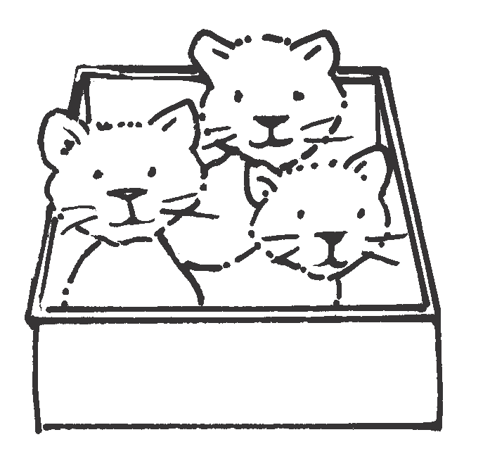

How many toy kittens are there  
in all?

A 1 toy kitten

B 3 toy kittens C 6 toy kittens D 9 toy kittens

**364**

**GO ON ►**

**Grade 3 • Benchmark Test 2**

I

0

**Read each question. Fill in the correct answer.**

*(Chapters 4-7)*

Name Date



**Benchmark Test 2**

8

12

4

9

3

6

2

3

1

**Number of**

**Pipe Cleaners**

**Number of**

**Animals**

**10.** Conrad hiked 36 miles in 4 days.

miles each day. How many miles   
did Conrad hike each day?

F 9 miles G 8 miles H 7 miles  
 I 6 miles

**7.** Ethan wants to check the division problem below.

6 ÷ 3 = 2

Which number sentence represents   
the inverse operation he can use?

A 3 + 3 = 6

B 6 – 3 = 3

C 2 × 3 = 6

D 3 + 2 = 6

**9.** Which number represents the

8 × = 40

A 4

B 5

C 6

D 7

**8.** Jake did 4 crunches the first day of

exercise class. He did 8 the second   
day, 12 the third day, and 16 the   
fourth day. If the pattern continues, how many crunches will Jake do   
on the fifth day?

F 18 crunches G 20 crunches H 22 crunches  
 I 24 crunches

**6.** Miguel makes animals out of pipe

cleaners. He uses 3 pipe cleaners   
to make 1 animal.

Look at the table.

How many pipe cleaners does it take to make 8 animals?

F 15 pipe cleaners G 18 pipe cleaners H 21 pipe cleaners I 24 pipe cleaners

**Grade 3 • Benchmark Test 2**

**GO ON ►**

**365**

He hiked the same number of

unknown factor below?

*(continued)*

Name Date

**Benchmark Test 2**

**15.** Nine bicycles are in a bicycle rack.

There are 2 wheels on each bicycle. How many wheels are there in all?

A 9 wheels

B 11 wheels C 18 wheels D 27 wheels

**12.** Morgan has 12 dolls. She put   
an equal number of dolls on

2 shelves.

How many dolls did she put on each shelf?

F 2 dolls

G 6 dolls

H 10 dolls

I 12 dolls

**14.** Dan bought 6 boxes of puzzles.

There are 10 puzzles in each box.  
How many puzzles are there in all?

F 10 puzzles

G 50 puzzles  
H 60 puzzles  
 I 70 puzzles

**13.** Which number sentence is true?

A 0 ÷ 3 = 0

B 0 ÷ 3 = 3

C 3 × 0 = 3

D 3 ÷ 1 = 1

**11.** Greg can wear either a yellow,

blue, or green soccer jersey with   
black or white shorts. How many   
jersey and shorts combinations can Greg make?

A 2 combinations B 3 combinations C 5 combinations D 6 combinations

**366**

**GO ON ►**

**Grade 3 • Benchmark Test 2**

*(continued)*

Name Date

**Benchmark Test 2**

**18.** Mandy has 18 charms. She wants  
to give 3 charms to each of her friends. How many friends could

F 5 friends

G 6 friends

H 15 friends

I 21 friends

**20.** Olivia has 16 animal pictures in   
her scrapbook. There are 4 animal pictures on each page. How many pages of animal pictures are in Olivia’s scrapbook?

F 4 pages

G 12 pages H 16 pages I 20 pages

**17.** Ernesto is hanging 12 pictures.

He hangs 3 pictures in each row. Ernesto use to find how many

A 12 – 3 – 3 – 3 = 3

C 3 + 3 + 3 = 9

D 12 + 3 = 15

**19.** Manual bought 6 packs of buttons.

There are 5 buttons in each pack.

How many buttons are there in all?

A 5 buttons

B 6 buttons

C 30 buttons

D 35 buttons

**16.** Kara sells friendship bracelets for

$4 each. She sold 70 bracelets.   
How much money did she make?

F $70

G $140

H $210

I $280

**Grade 3 • Benchmark Test 2**

**367**

equally share the charms?

12 ÷ 3 = 4

B

rows of pictures he can make?

Which number sentence can

*(continued)*

Name Date